Dear Members,
The weekly bulletin informs members recent initiatives, campaigns and more, so check it consistently to stay up-to-date with ways to grow your business.
RBC PAC Campaign - $2,000 Lump-Sum Bonus (January to March 2020)
Further to the RBC PAC training last Friday, eight members have already gotten first dips rewards and are on track to the ultimate $2,000 lump-sum bonus.
In addition, $600 in donations for the Vancouver General Hospital was raised by Way on eligible members’ behalf for completing a marketing exercise that at the same time helped members generate new client appointments.
There is still just over one-month to go for you to get this bonus and be on path to generate much more in residual income.
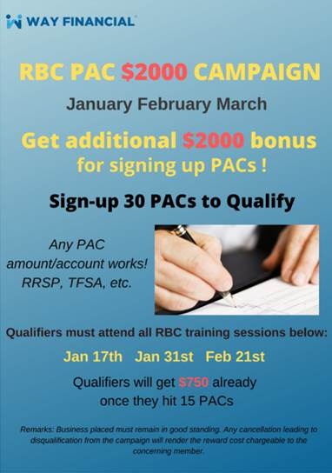

Upcoming Featured Trainings
Mandatory Annual Compliance Update – Stephen Lai (attendance required)
11am, Wednesday, February 26th
In addition to learning about new industry trends and updates to the KYC requirements, details on the 2020 Connection Campaign as well as recognition for existing connections will be announced. Come learn how to earn more income sustainably!
Lunch & Learn: How to use the New IA Critical Illness Insurance to gain 20% more in commissions: 10-pay, pricing and more – Rishu Bains
11am, Friday, February 28th
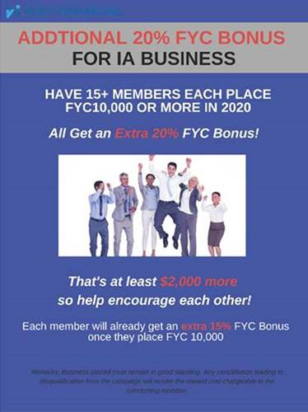
Way Insiders' News: Creating Easy Business Opportunities with an Exclusive Product Line - Sunny Chan
11am, Wednesday, Mar 4th

Join Sunny Chan, President of Prominence Financial, to see what strategies can be used to create conversations with professional clients.

RBC Webinar on Capital Markets
1pm, Tuesday, February 25th
Hear what Portfolio Specialist, Christian Chiera, has to say on the markets, including the impact of the COVID-19. Register and ask your questions directly here:
https://rbcteams.webex.com/rbcteams/onstage/g.php?MTID=ee03f52260103cd7295d2fa8998cdd6e7
Technical support: Keni Ng. His contact info: 604-699-2341 and rbciwwreq@rbc.com
Questions for portfolio specialist: You can either email Keni your questions or send them through the registration link above


20 Secrets that the Taxman Doesn’t Want You to Know – Orders Now Accepted
Further to members’ enquiries, you can place your order of the subject book via Coordinator@yourqna.com. Simply indicate the following in your e-mail:
Name:
Phone number:
Mailing address (for receipt purpose):
Number of copies:
Full payment can be made to QNA Technology Inc and can be dropped off at the Front Desk for on passing to the company.
The book is priced at $24.99 on Amazon and local bookstores, and sold for the same price at the Client Events.
For Way Members only, if you order 2 copies, you can bring your receipt to Accounting Department to claim a $20 sponsorship. That means you can get 2 copies for only $29.99 – one for yourself, one for your client.
If you want to order more, you can still get the $20 sponsorship for every 2 copies.
- Eg. If you order 4, you will get $40 sponsorship, so the total for 4 books is $59.99.
- Eg. If you order 10, you will get $100 sponsorship, so the total for 10 books is $149.95.
This is to encourage you to do more business and build a closer relation with your clients as the book will help you close cases after your clients read it. As you already know, the English version is a National Best Seller.
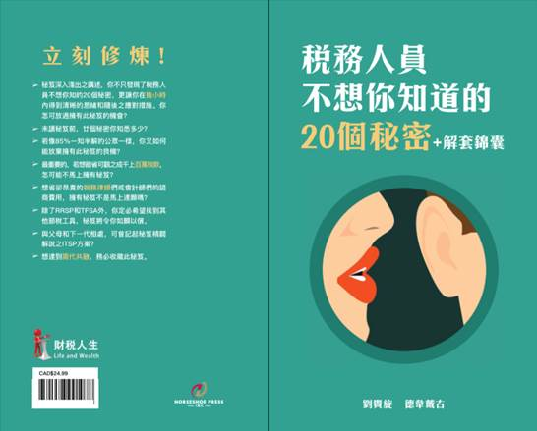

Canada Life New Illustration (4.2) effective February 24th, 2020
Check out the new illustration (4.2) and download it from the page here: Concourse Direct (see page 1 for the link to the illustration program).
Ask wholesaler, Carol Ng, for more details at Carol.Ng@CanadaLife.com or (604)377-7203.

RRSP Deadline Reminder – March 2nd, 2020
Please be reminded that all RRSP business must be signed and dated by March 2nd, 2020, and received by the office by 9:30am on March 3rd, 2020, to count towards the contribution for 2019. Feel free to ask your specific coordinator or e-mail process@wayfinancial.ca if you have any question.

News from the Insurance Council of British Columbia
Preparing for Annual Filing 2020
The annual filing fee will be announced in March, and filing will officially open on April 1st, 2020. Licensees are encouraged to update their contact information via the online portal so that they can receive annual filing communication from Council.
Disciplinary Decisions
Loretta Lai was subject to a condition on her life insurance licence following a October 26, 2016, order by the Insurance Council requiring her to only conduct insurance activities under direct supervision of a qualified life agent until certain proceedings by the BC Securities Commission (BCSC) were complete and had been subsequently considered by the Insurance Council. BCSC concluded its investigation with no findings against the licensee. However, the licensee’s spouse, a former Insurance Council licensee, was implicated and subsequently found liable by the BCSC. The spouse’s misconduct involved an insurance agency of which the licensee was both nominee and director at the material times.
After considering the matter, the Insurance Council ordered that the supervision condition imposed on the licensee’s life licence be removed and imposed new conditions prohibiting the licensee from acting as a supervisor for a period of two years and permanently prohibiting her from being or acting as a nominee of any agency, and/or an officer, director, or shareholder of any corporation licensed with the Insurance Council of BC.
See Council’s website for the full list of disciplinary decisions.

Events Schedule – March (updated)
The updated Events Schedule for March is attached for your reference.

